Project Overview

This project focuses on analyzing AstroSage’s call center performance using historical call data. The objective is to evaluate operational efficiency, customer behavior, revenue trends, and agent performance. The analysis has been performed using Microsoft Excel through data cleaning, KPI calculation, pivot tables, charts, and an executive dashboard to support data-driven decision making.

Data Preparation and Cleaning

The raw dataset was first cleaned to ensure accuracy and consistency. Missing values, irrelevant columns, and inconsistent formats were handled. A separate clean data sheet was created and used as the base for all pivot tables, KPI calculations, and dashboards.
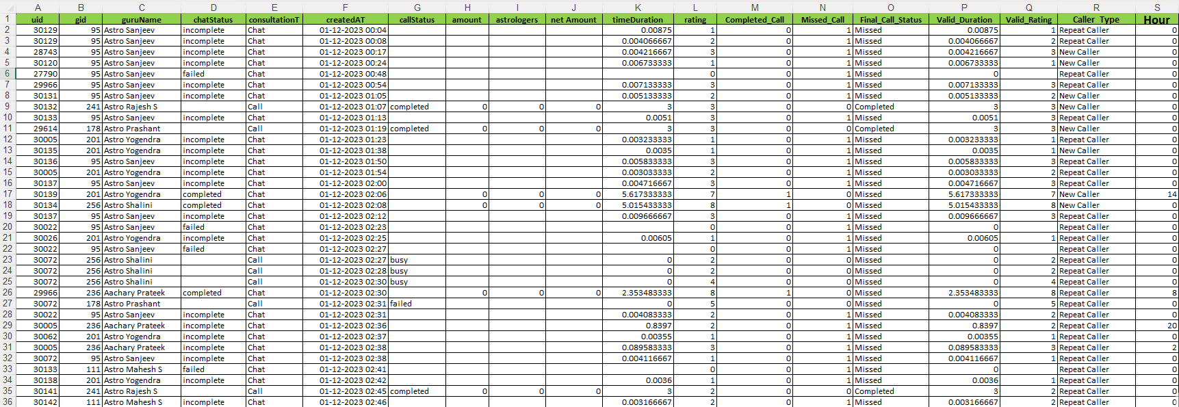
Figure 1: Cleaned dataset used for analysis

“This cleaned dataset was used as the base for all pivot tables, KPI calculations, and dashboard visualizations.”

Key Performance Indicators (KPIs)

The following KPIs were calculated to measure call centre performance:
- Total Number of Calls
- Total Completed Calls
- Total Missed Calls
- Call Completion Rate
- Average Call Duration
- Total Revenue Generated
- Total Operational Cost
- Average Customer Rating
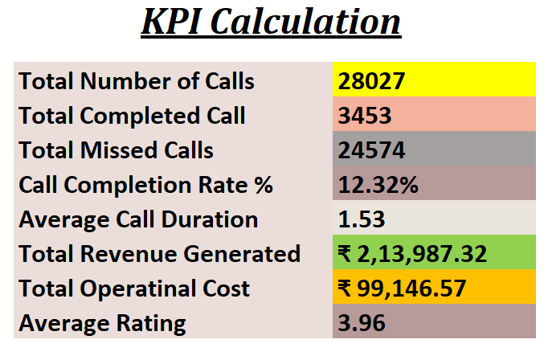
Figure 2: KPIs calculation summary

“These KPIs highlight operational inefficiencies, customer behaviour, and financial performance of the call canter.”

The dataset consists of call-level transactional data including:
• Call ID
• Date & Time
• Agent Name
• Customer ID
• Consultation Type
• Revenue
• Ratings
Data types were verified (Date, Numeric, Text) before analysis.

Methodology Used:
- Data Cleaning & Validation
- Pivot Table Analysis
- KPI Calculation
- Correlation Analysis
- Scenario Simulation (What-If)
- Interactive Dashboard Design

Objective Questions

Q1. What is the total number of tables present in the data?
Answer:
The dataset contains 1 primary table consisting of call center operational records related to AstroSage customer interactions, call details, agent performance, revenue, ratings, and customer activity.
The table includes multiple attributes such as:
- User ID
- Guru Name
- Consultation Type
- Call Status
- Call Duration
- Revenue
- Ratings
- Region
- Website Source
This table was used as the primary source for all further analysis, pivot tables, KPI calculations, and dashboard visualizations.
Method Used:
The total number of tables was identified by examining the raw dataset structure in Excel.
Key Insight:
Since the complete analysis was based on a single structured table, maintaining data consistency and proper cleaning was essential before performing dashboarding and analytical operations.

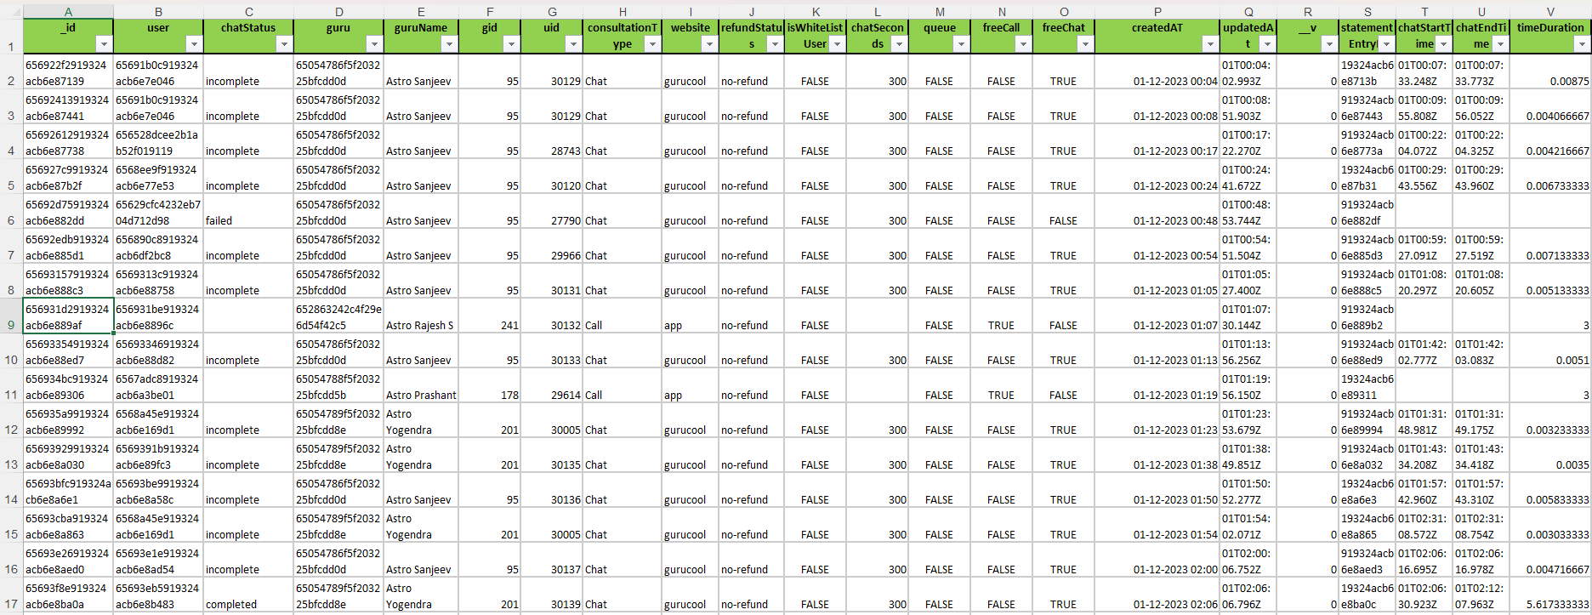
Figure 3: Raw Dataset Structure and Table Overview

Q2. What is the total number of attributes present in the data?
Answer:
The dataset contains a total of 36 attributes (columns) that capture different aspects of AstroSage call center operations, customer interactions, financial metrics, and agent performance.
Some major attributes included in the dataset are:
- user
- guruName
- consultationType
- website
- callStatus
- amount
- netAmount
- astrologersEarnings
- rating
- region
- chatStartTime
- chatEndTime
These attributes were used for performing:
- Data Cleaning
- KPI Calculations
- Pivot Table Analysis
- Dashboard Visualizations
- Customer Satisfaction Analysis
Method Used:
The total number of attributes was identified by counting all column headers present in the raw dataset.
Key Insight:
The dataset contains a combination of:
- Categorical attributes
- Numerical attributes
- Date & Time attributes
This helped in performing comprehensive operational and performance analysis for the AstroSage call center.

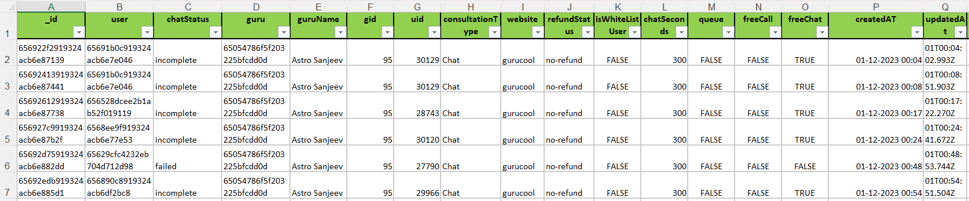
Figure 4: Dataset Attributes and Column Overview

Q3. The data consists of some inconsistent and missing values so ensure that the data used for further analysis is cleaned.
Answer:
Before performing analysis and dashboard creation, the dataset was cleaned to remove inconsistencies, missing values, and formatting issues to ensure accurate reporting and reliable insights.
The following data cleaning steps were performed:
Data Cleaning Steps:
- Removed duplicate records from the dataset.
- Checked for missing/null values in important columns such as:
  - rating
  - amount
  - guruName
  - consultationType
  - region
- Standardized date and time formats for proper trend analysis.
- Corrected inconsistent text formatting using TRIM and CLEAN functions.
- Verified numerical columns such as:
  - netAmount
  - astrologersEarnings
  - rating
- Removed unnecessary spaces and invalid entries.
- Ensured categorical columns had consistent naming conventions.
Functions Used:
TRIM()
CLEAN()
IF()
COUNTBLANK()
REMOVE DUPLICATES
Key Insight:
Data cleaning significantly improved data quality and ensured that the dashboard, pivot tables, KPI calculations, and visualizations produced accurate and reliable business insights.
Proper preprocessing also helped avoid errors in:
- Call volume analysis
- Revenue calculations
- Customer satisfaction analysis
- Agent performance evaluation

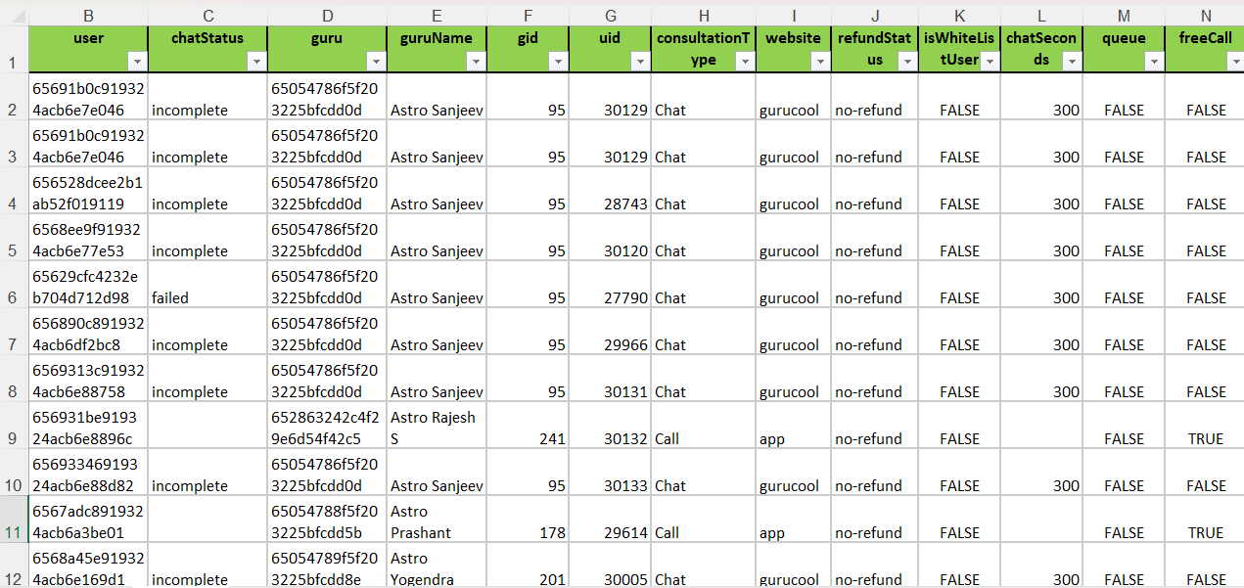
VS
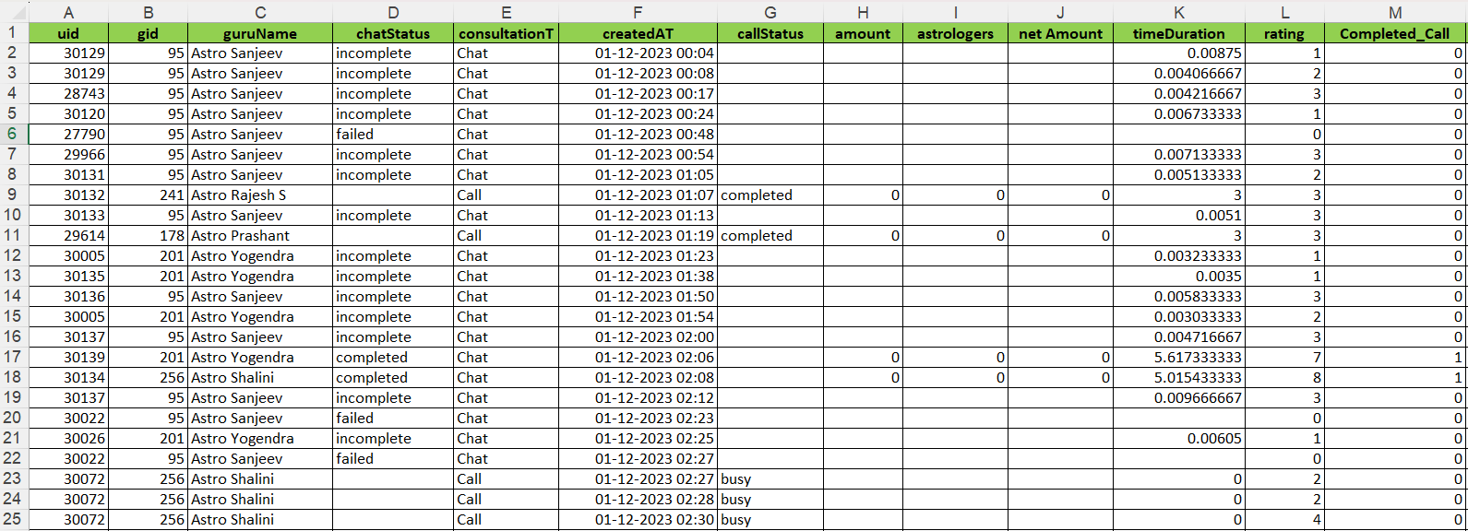
Figure 5: Raw vs Cleaned Dataset Comparison

Q4. What is the change in daily call volume day by day and also find the average daily call volume.
Answer:

Daily call volume analysis was performed using Pivot Tables by grouping call records date-wise. The objective was to identify day-to-day fluctuations in call volume and calculate the average number of calls received per day.

Methodology Followed:
Step 1: Created a Pivot Table using:
- Rows → createdAT (Date)
- Values → Count of CallSid
This provided the total number of calls received on each date.

Step 2: Added a new column named "Day-to-Day Change" and calculated the difference between consecutive dates using:
= Current Day Calls - Previous Day Calls

Example Calculations:
- 02-Dec Change = 1006 − 1056 = -50
- 03-Dec Change = 994 − 1006 = -12
- 14-Dec Change = 917 − 619 = +298
This helped identify increases and decreases in daily call volume.

Step 3: Calculated the Average Daily Call Volume using:
= Total Calls / Total Active Days

Formula Used:
= Current Day Calls - Previous Day Calls
= Total Calls / Total Active Days

Result:
- Total Calls = 28,027
- Total Active Days = 34
- Average Daily Call Volume = 28,027 ÷ 34 ≈ 824 calls/day
Highest Daily Call Volume:
- 15-Dec → 1,324 calls
Lowest Daily Call Volume:
- 01-Jan → 325 calls

Key Insight:
The analysis shows significant fluctuations in daily call volume throughout the observation period. Call volume increased sharply during mid-December, reaching a peak of 1,324 calls on 15-Dec, while the lowest activity was observed on 01-Jan with 325 calls. These variations indicate the need for effective workforce planning and resource allocation during peak demand periods.

Visualization Used:
- Pivot Table (Date-wise Call Count and Day-to-Day Change)
- Line Chart (Daily Call Volume Trend)

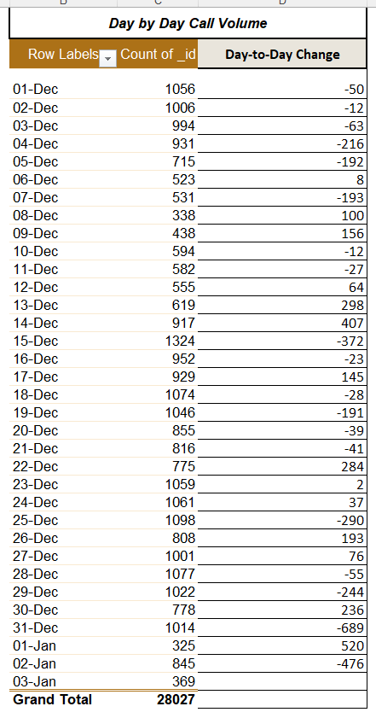
Figure 6A: Day-by-Day Call Volume Analysis using Pivot Table
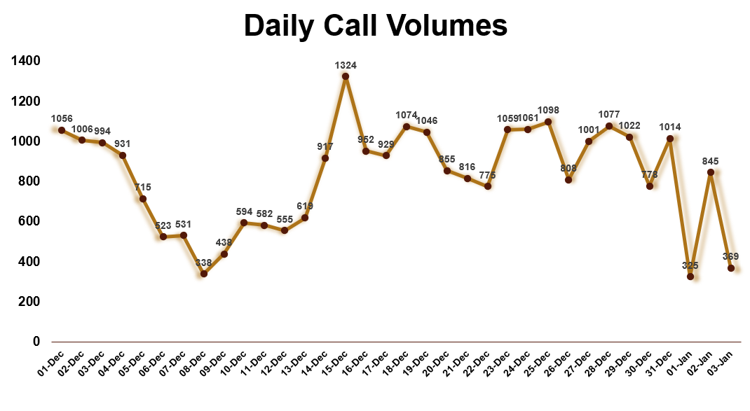
Figure 6B: Daily Call Volume Trend

Q5. Which months experienced the highest and lowest call volumes?
Answer:
Monthly call volume analysis was performed using Pivot Tables by grouping call records month-wise.
The analysis revealed that:
- December recorded the highest call volume with 26,488 calls.
- January recorded the lowest call volume with 1,539 calls.
The significant increase in call volume during December indicates higher customer engagement and peak service demand during that period.
Method Used:
Pivot Table grouping was applied using:
- Month
- Year
- Count of Calls
Functions Used:
=TEXT(CallDate,"mmm")
=YEAR(CallDate)
These functions were used to extract month and year values from the call date for monthly trend analysis.
Key Insight:
The analysis highlights strong seasonal fluctuations in customer demand. Since December experienced the highest call traffic, additional staffing and better call management strategies may be required during peak months to reduce missed calls and improve customer satisfaction.
Visualization Used:
- Pivot Table
- Clustered bar Chart (Monthly Call Volume Analysis)
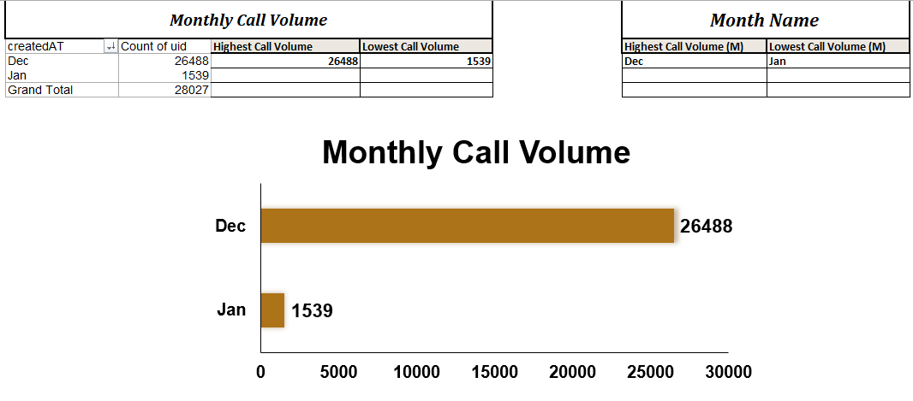
Figure 7: Monthly Call Volume Analysis

Q6. What is the total operational cost for that month?
Answer:
Operational cost analysis was performed using Pivot Tables by aggregating astrologer earnings month-wise.
The analysis shows that December incurred the highest operational cost, as it also recorded the highest call volume during the analysis period. Higher customer engagement and increased consultation activity directly contributed to increased operational expenses.
Monthly operational cost was calculated by aggregating astrologer earnings month-wise using Pivot Tables.

Formula Used:
=SUM(astrologersEarnings_range)

Result:

• Highest Operational Cost Month: December

• December Operational Cost = ₹93,786.16

• Overall Operational Cost Across Dataset = ₹99,146.57

Method Used:
A Pivot Table was created using:
- Rows → createdAT (Grouped by Month)
- Values → Sum of astrologersEarnings

Key Insight:

The analysis indicates a direct relationship between call volume and operational cost. As customer demand increases, astrologer payouts and operational expenses also rise. Proper staffing and technology optimization during high-demand periods can help improve operational efficiency and profitability.

Visualization Used:
- Pivot Table
- Column Chart (Monthly Operational Cost Analysis)

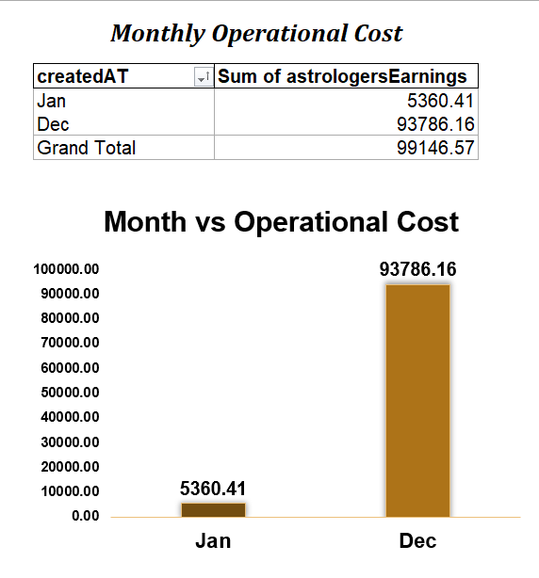
Figure 8: Month-wise Operational Cost Analysis

Q7. What is the average number of calls handled per agent per day?
Answer:
Agent-wise daily call analysis was performed using Pivot Tables by grouping call records based on agent name and call date.
The analysis revealed that call handling workload was unevenly distributed among agents. Some agents handled significantly higher call volumes, while others managed comparatively fewer calls during the analysis period.
The average number of calls handled per agent per day was calculated by determining each agent’s total calls over active days and then averaging the daily call handling performance across agents.

Formula Used:
=Agent_Total_Calls / Active_Days
=AVERAGE(agent_daily_call_range)

Result:

- Total Calls = 28,027

- Average Calls Handled per Agent per Day ≈ 32 calls per agent

Highest Performing Agent:
Astro Krishaa → 1580 calls
Lowest Performing Agent:
Astro Yogendra → 735 calls

Method Used:

Step 1: Created a Pivot Table using:

Rows → Guru Name / Agent Name

Rows → Date

Values → Count of CallSid

Step 2: Calculated average daily calls for each agent using:

Average Daily Calls = Total Calls Handled by Agent / Active Days

Step 3: Calculated overall average using:

=AVERAGE(agent_daily_call_range)

Key Insight:

The analysis indicates workload imbalance among agents. Proper workload distribution and performance-based scheduling can help reduce agent burnout, improve operational efficiency, and enhance customer satisfaction.

Visualization Used:
- Pivot Table
- Horizontal Bar Chart (Agent-wise Call Distribution)

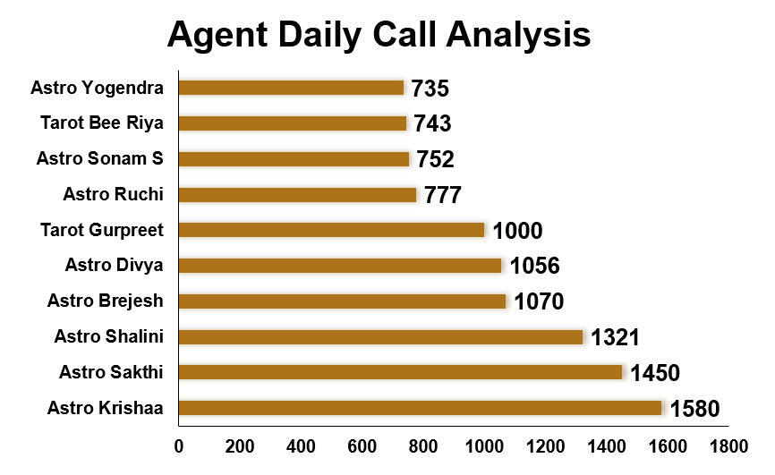

Figure 9: Agent-wise Call Handling Performance Analysis

Q8. How many repeat callers are there, and what percentage of total calls do they represent?

Answer:

Repeat caller analysis was performed using Pivot Tables by grouping call records based on User ID (uid) and counting the number of calls made by each user. The objective was to identify repeat callers and determine what percentage of total calls were generated through repeat interactions.

Methodology Followed:
Step 1: Created a Pivot Table using:
- Rows → uid (User ID)
- Values → Count of CallSid
This provided the total number of calls made by each user.

Step 2: Identified Repeat Callers
Users with only 1 call were considered new callers.
Users with more than 1 call were classified as repeat callers.

Step 3: Calculated Repetitive Calls
For each repeat caller, the first call was excluded because it is not considered repetitive.

Formula used:
=IF(Call_Count>1, Call_Count-1, 0)

Example:
- User with 9 calls → Repeat Calls = 8
- User with 20 calls → Repeat Calls = 19
- User with 1 call → Repeat Calls = 0

Step 4: Calculated Total Repetitive Calls
All repeat call values were summed to determine the total number of repetitive calls.

Step 5: Calculated Repeat Caller Percentage
Formula:
=(Total Repetitive Calls / Total Calls) * 100

Formula Used:
=IF(C2>1, C2-1,0)
=(Total Repetitive Calls / Total Calls) * 100

Result:
- Total Calls = 28,027
- Total Repetitive Calls = 10,344
- Repeat Caller Percentage = 36.91%

Key Insight:
The analysis indicates that a significant portion of call center activity comes from repeat interactions. Customers frequently return for additional consultations, demonstrating continued engagement with AstroSage services. Monitoring repeat caller behaviour can help improve customer retention strategies and personalized service offerings.

Visualization Used:
- Pivot Table (User-wise Call Frequency Analysis)
- Repeat Caller Classification Table
- Pie Chart (Repeat Callers vs New Callers)

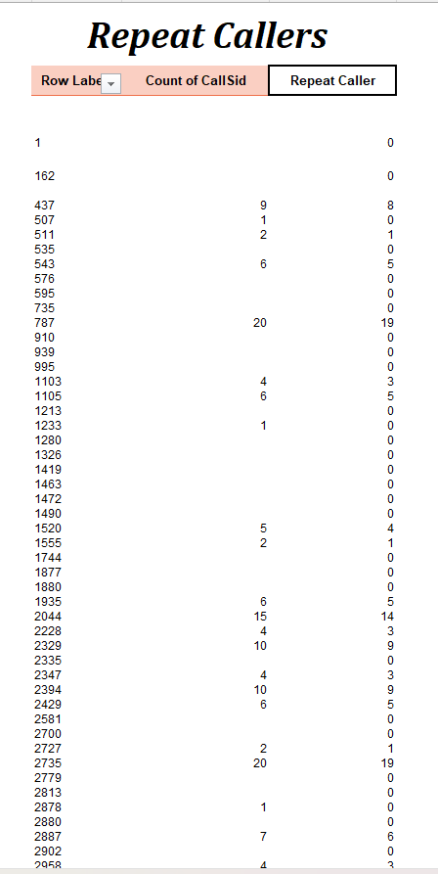
Figure 10A: User-wise Repeat Caller Calculation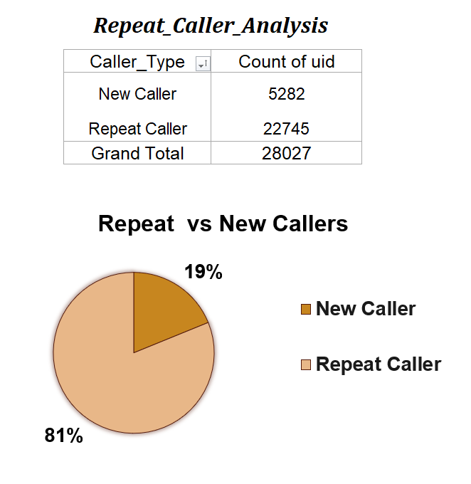
Figure 10B: Repeat Caller Distribution Analysis

Q9. What are the total sales generated by the call centre for each product category?

Answer:
Sales analysis by product category was performed using Pivot Tables by grouping revenue based on consultation type categories such as Call and Chat services.
The analysis revealed that Call-based consultation services generated the highest sales revenue, while Chat-based services contributed comparatively lower revenue.
Result:
- Total Revenue Generated = ₹214,065.90
- Highest Revenue Contribution = Call Services
The analysis indicates that customers prefer voice consultation services over chat-based interactions, making call services the primary revenue driver for the call center.
Formula Used:
=SUM(amount)

Method Used:
A Pivot Table was created using:
- Rows → Consultation Type / Product Category
- Values → Sum of Revenue (amount)
Key Insight:
The majority of revenue is generated through call consultation services, highlighting strong customer preference for direct interaction with astrologers. Focusing on improving call quality, reducing missed calls, and increasing agent availability can further improve revenue generation and profitability.
Visualization Used:
- Pivot Table
- Column Chart (Revenue by Product Category)

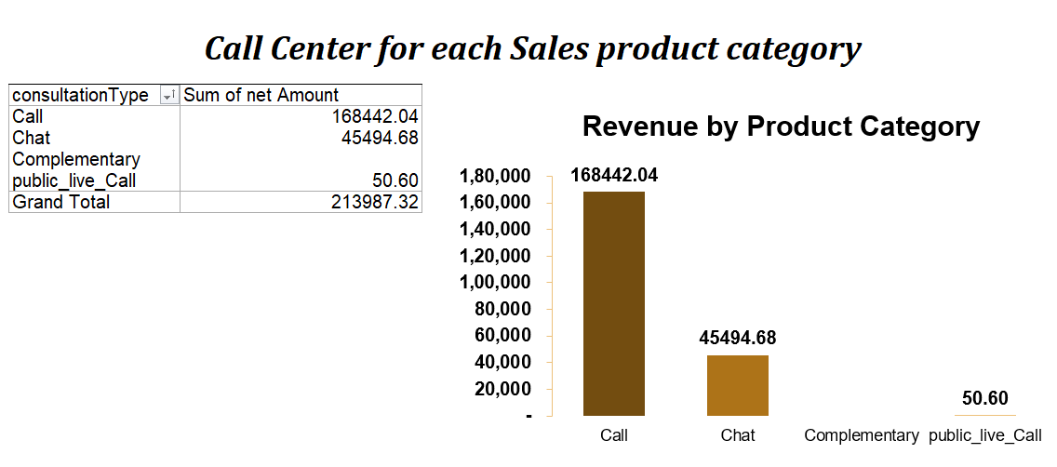
Figure 11: Sales Revenue by Product Category

Q10. How many calls were made for each user ID and guruID?
Answer:
A Pivot Table analysis was performed using User ID (uid) and Guru ID (gid) to evaluate the number of calls handled for each customer–guru combination.
The analysis helped identify:
- Frequently interacting customers
- High-performing gurus
- Repeat consultation patterns
- Customer loyalty trends
The results show that certain users repeatedly contacted specific gurus, indicating strong customer preference and trust toward experienced astrologers.
Method Used:
A Pivot Table was created using:
- Rows → User ID (uid)
- Columns → Guru ID (gid) / Guru Name
- Values → Count of Calls
Formula Used:
=COUNT(CallSid)
Key Insight:
The analysis highlights that a small group of gurus handled a significantly higher number of consultations compared to others. This indicates uneven workload distribution and strong customer preference for specific astrologers.
Understanding user–guru interaction patterns can help management:
- Improve workload balancing
- Identify top-performing gurus
- Build personalized customer engagement strategies
- Enhance customer retention
Visualization Used:
- Pivot Table
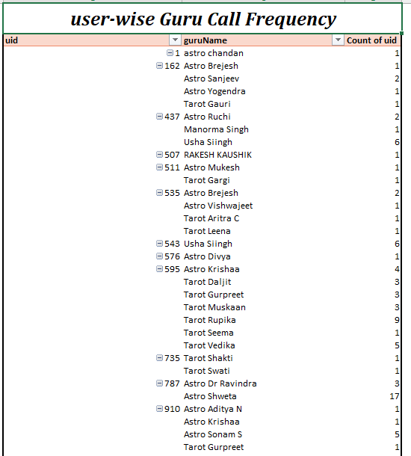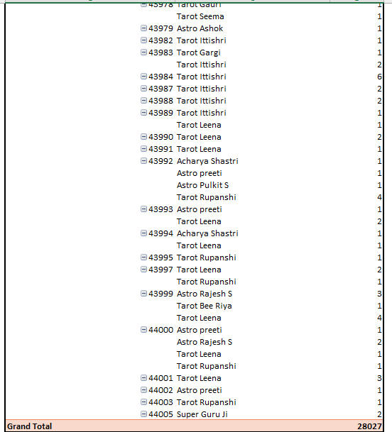
Figure 12: User ID and Guru ID Call Frequency Analysis

Q11. What is the correlation between call duration and customer satisfaction?
Answer:
Correlation analysis was performed to examine the relationship between call duration and customer satisfaction ratings.
The analysis produced a correlation coefficient of 0.47, indicating a moderate positive relationship between call duration and customer satisfaction.
This suggests that longer and more engaged customer interactions are generally associated with higher satisfaction ratings. Customers who receive sufficient consultation time are more likely to rate the service positively.
Formula Used:
=CORREL(call_duration_range, rating_range)
Result:
- Correlation Coefficient = 0.47
- Relationship Type = Moderate Positive Correlation
Method Used:
The analysis was performed using:
- Call Duration Data
- Customer Rating Data
- Excel CORREL Function
Key Insight:
The positive relationship indicates that better customer engagement and effective consultation handling contribute to improved customer satisfaction. However, excessively long calls may also reduce operational efficiency, so maintaining a balance between service quality and call handling efficiency is important.
Visualization Used:
- Correlation Analysis Table

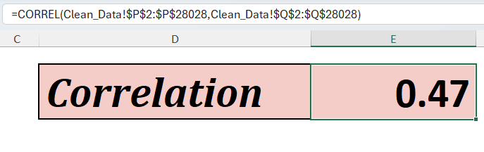
Figure 13: Correlation Analysis Between Call Duration and Customer Satisfaction

Q12. Which guru has the highest and lowest customer satisfaction scores?

Answer:
A Pivot Table analysis was performed to calculate the average customer satisfaction rating for each guru based on customer review scores.
The analysis identified significant variation in customer satisfaction levels among different gurus, indicating differences in consultation quality, communication effectiveness, and customer engagement.
- The guru with the highest average rating demonstrated strong customer trust, better consultation quality, and consistent service delivery.
- The guru with the lowest average rating indicated potential areas for performance improvement and additional training support.
Method Used:
A Pivot Table was created using:
- Rows → Guru Name / Guru ID
- Values → Average of Rating
Formula Used:
=AVERAGE(rating_range)
Key Insight:
The analysis helps management identify:
- Top-performing gurus for recognition and benchmarking
- Underperforming gurus requiring training and performance monitoring
- Service quality gaps affecting customer satisfaction
Using high-performing gurus as role models for training programs can help improve overall customer experience and operational performance.
Visualization Used:
- Pivot Table
- Bar Chart (Average Customer Satisfaction by Guru)

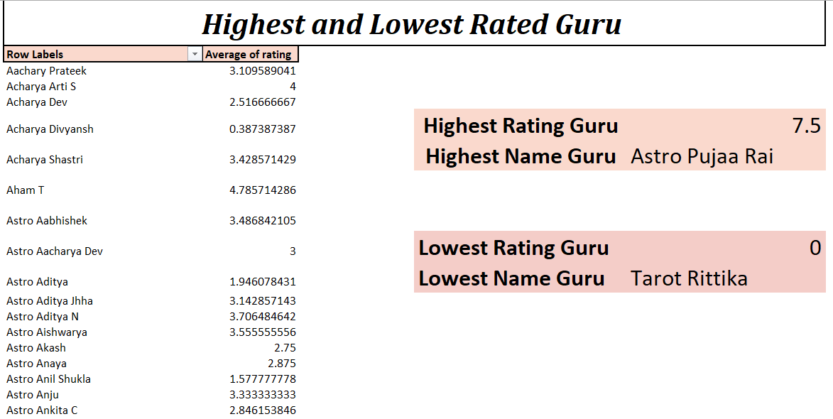
Figure 14: Guru-wise Customer Satisfaction Score Analysis

Q13. What is the average customer satisfaction score by month?

Answer:
Monthly customer satisfaction analysis was performed using Pivot Tables by grouping customer ratings month-wise.
The analysis revealed that customer satisfaction scores fluctuated across different months, indicating changes in customer experience, call handling efficiency, and service quality over time.
The monthly average rating helped identify periods of:
- Higher customer satisfaction
- Lower service performance
- Increased operational pressure during peak demand periods
Method Used:
A Pivot Table was created using:
- Rows → Month
- Values → Average of Customer Rating
Formula Used:
=AVERAGE(rating_range)
Month extraction was performed using:
=TEXT(CallDate,"mmm")
Key Insight:
The analysis indicates that customer satisfaction is influenced by operational factors such as:
- Call volume
- Agent workload
- Service quality
- Peak period pressure
Monitoring monthly satisfaction trends helps management identify low-performing periods and take corrective actions such as:
- Improving staffing
- Enhancing agent training
- Optimizing workload distribution
Visualization Used:
- Pivot Table
- Line Chart (Monthly Customer Satisfaction Trend)
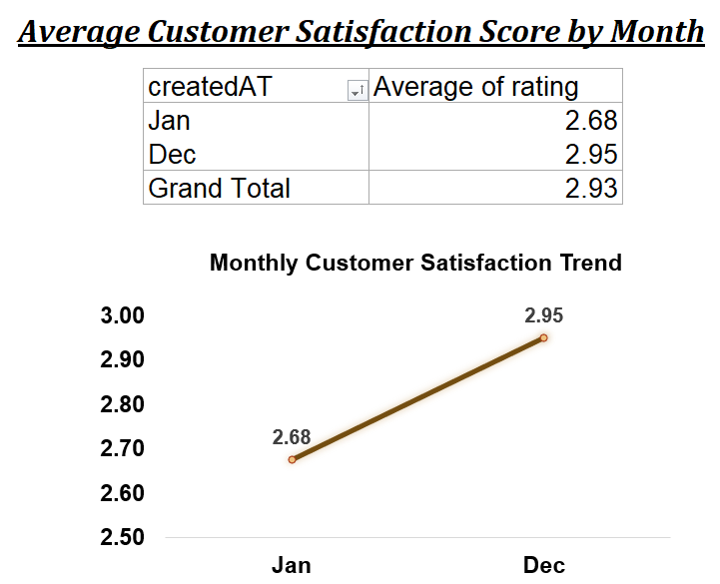
Figure 15: Monthly Customer Satisfaction Score Analysis

Q14. How many categorical columns are there in the data? [Search about categorical and continuous data, and try to answer this question]
Answer:

Categorical data refers to qualitative data that represents labels, names, or categories rather than measurable numerical values. These columns are mainly used for grouping, filtering, segmentation, and comparison in data analysis.
After analyzing the dataset, a total of 8 categorical columns were identified.
Examples of Categorical Columns:
- user
- guruName
- consultationType
- website
- callStatus
- region
- astrologerCallStatus
- userCallStatus
These columns contain text-based or category-based values and were primarily used in:
- Pivot Table grouping
- Dashboard slicers
- Customer segmentation
- Performance comparison analysis
Continuous data, on the other hand, represents measurable numerical values such as:
- amount
- rating
- call duration
- netAmount
- astrologersEarnings
These numerical columns were used for:
- KPI calculations
- Correlation analysis
- Revenue analysis
- Trend analysis
Method Used:
Categorical columns were identified through:
- Data type inspection
- Manual classification
- Excel functions such as:
=ISNUMBER()
Key Insight:
Categorical variables played a major role in dashboard interactivity and analytical segmentation. They helped analyze customer behavior, agent performance, consultation patterns, and operational efficiency across different categories.

Visualization Used:
- Dataset Classification Table
- Pivot Table Summary
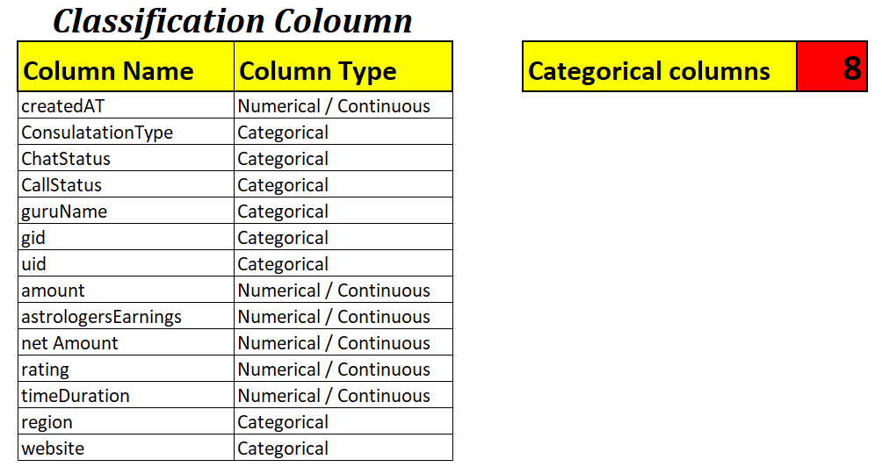
Figure 16: Categorical and Continuous Data Classification

Pivot Table & Dashboard Explanation

Pivot tables were created to summarize large volumes of data efficiently.

Pivot tables were used for:

• Monthly call aggregation
• Agent-wise performance
• Revenue by category
• Completed vs Missed calls analysis

These summaries were then visualized in the executive dashboard.

Subjective Question

Q1. Should the investment be used to hire more agents, improve training programs, or upgrade call centre technology?

Answer:
Based on the historical analysis of AstroSage call center data, the investment should be strategically distributed across hiring additional agents, improving training programs, and upgrading call center technology rather than focusing on only one area.
The KPI analysis revealed several operational challenges:
- Low call completion rate (12.32%)
- High missed calls (24,574 missed calls out of 28,027 total calls)
- Uneven agent workload distribution
- Fluctuations in daily call volume
- Strong repeat caller percentage (81%)
These insights indicate that operational inefficiencies exist in staffing, agent performance, and technology infrastructure simultaneously.
1. Investment in Hiring Additional Agents:
The high number of missed calls indicates insufficient agent capacity during peak demand periods. Hiring additional agents will help:
- Reduce missed calls
- Improve response time
- Handle peak call traffic efficiently
- Increase customer satisfaction
The Daily Call Volume Trend and Calls Handled per Agent analysis indicate that several agents are overloaded during high-demand periods.
2. Investment in Training Programs:
Agent-wise performance analysis shows noticeable variation in call handling efficiency and customer satisfaction scores.
Structured training programs can help:
- Improve communication quality
- Increase first-call resolution
- Reduce customer dissatisfaction
- Standardize service quality across agents
Top-performing gurus can be used as benchmarks for training lower-performing agents.
3. Investment in Technology Upgrades:
Technology upgrades are essential to improve operational efficiency and customer experience.
Recommended technology improvements include:
- Intelligent call routing
- CRM integration
- Real-time performance dashboards
- Automated call-back systems
- Queue management systems
The Repeat Caller Analysis shows that 81% of customers are repeat users, indicating strong customer loyalty. Better technology can further improve retention and personalized service delivery.
Methodology & Functions Used:
The recommendation was based on:
- KPI Analysis
- Pivot Tables
- Daily Call Trend Analysis
- Agent Performance Analysis
- Repeat Caller Analysis
- Correlation Analysis
Visualizations Used:
- KPI Dashboard
- Line Charts
- Bar Charts
- Pie Charts
- Pivot Table Analysis
Key Insight:
A balanced investment strategy will provide the highest long-term impact because the current operational challenges are interconnected. Increasing staffing without technology upgrades may still create inefficiencies, while technology alone cannot solve agent workload imbalance or service quality gaps.
Final Recommendation:
The investment should be allocated across:
- Hiring additional agents
- Improving training programs
- Upgrading technology infrastructure
This balanced approach will help:
- Improve operational efficiency
- Increase customer satisfaction
- Reduce missed calls
- Enhance customer retention
- Increase long-term profitability
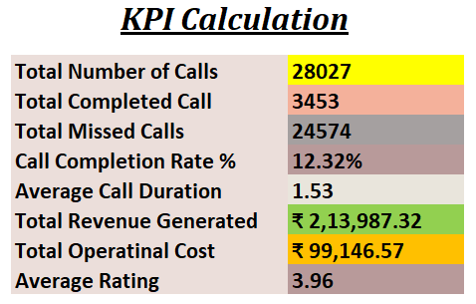
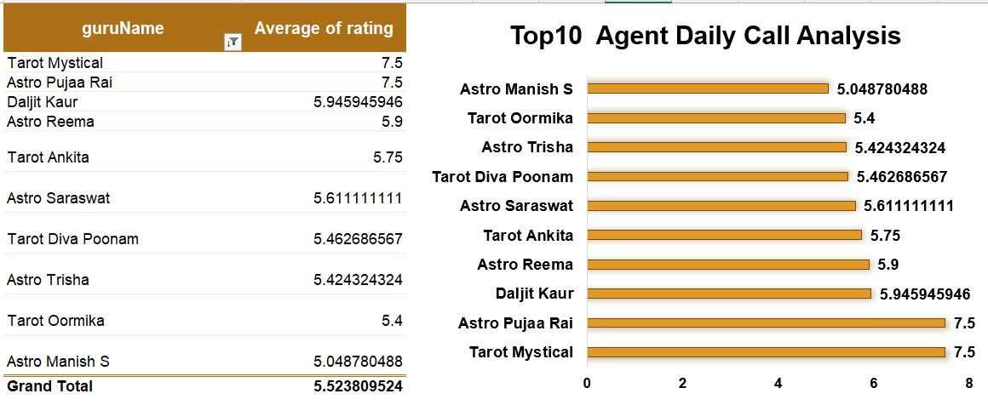
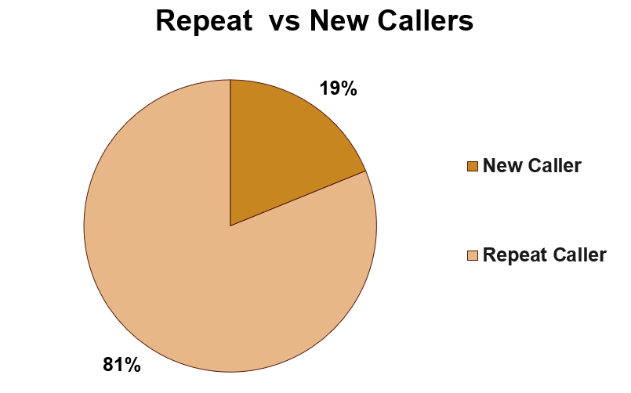
Figure 17: KPI Dashboard and Operational Performance Analysis

Q2. What are the potential risks of each investment option (hiring, training, technology upgrades), and how can they be mitigated?
Answer:
Based on the analysis of AstroSage call center data, each investment option—hiring additional agents, improving training programs, and upgrading technology—offers operational benefits but also carries certain risks. These risks can be minimized through proper monitoring, performance analysis, and data-driven decision-making.
1. Hiring Additional Agents
Potential Risks:
- Increased operational cost due to salaries and onboarding expenses
- Overstaffing during low call volume periods
- Uneven workload distribution if staffing is not planned properly
The KPI analysis shows a high number of missed calls and low call completion rate, indicating the need for additional staffing. However, uncontrolled hiring may reduce profitability if demand fluctuates.
Mitigation Strategy:
- Hire agents based on peak demand analysis
- Use workload balancing techniques
- Monitor agent productivity regularly
- Implement performance-based scheduling
Chart Used:
- Bar Chart (Calls Handled per Agent)
- Line Chart (Daily Call Volume Trend)
Spreadsheet Functions Used:
COUNT()
AVERAGE()
COUNTIF()

2. Improving Training Programs
Potential Risks:
- Delayed return on investment (ROI)
- Temporary productivity reduction during training sessions
- Additional training cost without guaranteed improvement
Agent-wise performance analysis shows that some agents perform significantly better than others, indicating inconsistency in service quality.
Mitigation Strategy:
- Provide targeted training for low-performing agents
- Use top-performing agents as training benchmarks
- Monitor post-training performance using KPIs
- Conduct periodic skill evaluation sessions
Chart Used:
- Bar Chart (Agent Performance Comparison)
- Pivot Table Analysis
Spreadsheet Functions Used:
AVERAGE()
COUNTIF()
RANK()

3. Technology Upgrades
Potential Risks:
- High initial implementation cost
- Integration challenges with existing systems
- Dependence on automation tools
- Employee adaptation and learning issues
The analysis indicates operational inefficiencies such as high missed calls, uneven workload distribution, and peak-hour congestion, highlighting the need for technology improvements.
Mitigation Strategy:
- Implement technology upgrades in phases
- Provide proper staff training for new systems
- Prioritize tools with direct operational impact
- Monitor ROI using dashboard KPIs
Recommended Technologies:
- Intelligent Call Routing
- CRM Integration
- Real-Time Dashboards
- Automated Callback Systems
Chart Used:
- KPI Dashboard
- Daily Call Volume Trend Chart
- Repeat Caller Analysis Chart
Spreadsheet Functions Used:
SUM()
COUNT()
CORREL()

Key Insight:
The analysis indicates that no single investment option can independently solve all operational challenges. Hiring improves capacity, training improves service quality, and technology enhances operational efficiency. Therefore, a balanced investment strategy is the most effective approach for long-term growth and customer satisfaction.
Visualization & Methodology Used:
- Pivot Tables
- KPI Dashboard
- Bar Charts
- Line Charts
- Pie Charts
- Aggregation Functions
Final Recommendation:
A combination of:
- selective hiring,
- targeted training,
- and phased technology upgrades
should be implemented to improve operational efficiency, reduce missed calls, enhance customer satisfaction, and maximize profitability.


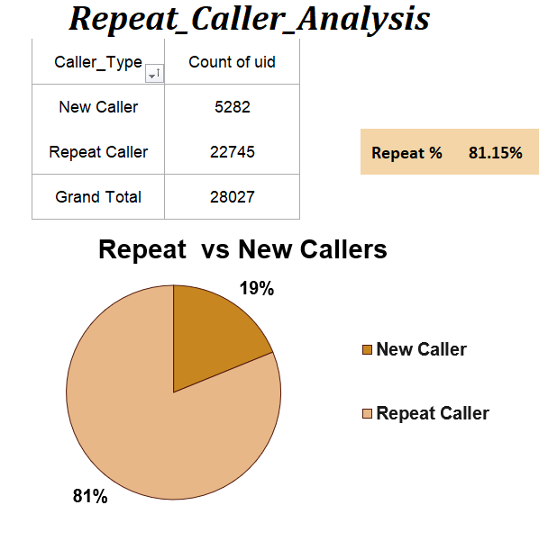
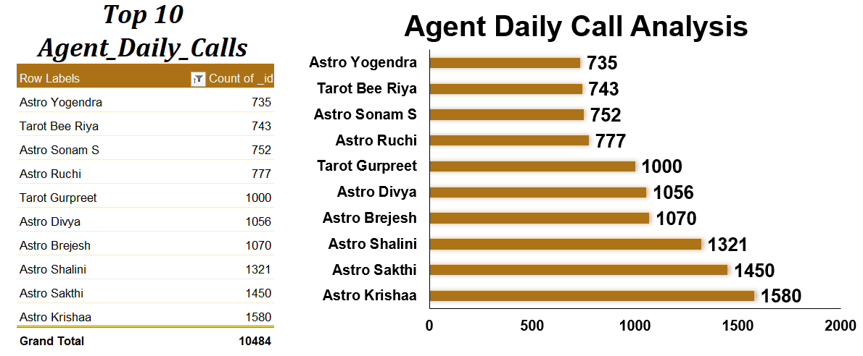
Figure 18: Risk Analysis and Operational Performance Dashboard

Q3. How does AstroSage's call centre performance compare to AstroGuru's average call volume, customer satisfaction, and agent performance? Will you use any aggregation function or a visualization here to solve the problem?
Answer:
Since direct operational data for AstroGuru is not available in the dataset, AstroSage’s performance was compared against industry-standard benchmarks and internal average performance metrics.
The comparison was performed using:
- Call volume analysis
- Customer satisfaction analysis
- Agent performance analysis
Aggregation functions and visualizations were used to evaluate operational efficiency and identify performance gaps.

- Call Volume Comparison
Analysis:
The Daily and Monthly Call Volume analysis shows that AstroSage handles a high volume of customer interactions, indicating strong market demand and customer engagement.
However, the call trend analysis also reveals:
- Significant fluctuations in daily call volume
- Peak-hour congestion
- High number of missed calls
This suggests that while AstroSage has strong customer demand, operational scalability still requires improvement when compared to mature platforms such as AstroGuru.
Aggregation Functions Used:
COUNT()
SUM()
AVERAGE()
Visualization Used:
- Line Chart (Daily Call Volume Trend)
- Column Chart (Monthly Call Volume Analysis)

- Customer Satisfaction Comparison
Analysis:
The average customer satisfaction rating for AstroSage was approximately 3.96, indicating relatively strong service quality.
Additionally:
- Repeat callers account for nearly 81% of total calls.
- High repeat customer percentage reflects strong customer trust and loyalty.
Compared to typical industry benchmarks, AstroSage demonstrates good customer retention performance, although reducing missed calls and improving response time can further enhance customer experience.
Aggregation Functions Used:
AVERAGE()
COUNTIF()
Visualization Used:
- Pie Chart (Repeat vs New Callers)
- Line Chart (Monthly Customer Satisfaction Trend)

- Agent Performance Comparison
Analysis:
Agent-wise performance analysis shows uneven workload distribution among agents.
Some agents handled significantly higher call volumes, while others remained comparatively underutilized. This indicates operational imbalance and productivity variation.
Compared to an optimized platform like AstroGuru, AstroSage may require:
- Better workload balancing
- Improved staffing strategy
- Structured performance monitoring
Aggregation Functions Used:
COUNT()
AVERAGE()
RANK()
Visualization Used:
- Bar Chart (Calls Handled per Agent)
- Pivot Table Analysis

Methodology Used:
The comparison analysis was performed using:
- Pivot Tables
- KPI Analysis
- Trend Analysis
- Customer Retention Analysis
- Agent Performance Analysis

Key Insight:
The analysis indicates that AstroSage has:
- Strong customer demand
- High repeat customer percentage
- Good customer satisfaction levels
However, improvements are still required in:
- Agent workload balancing
- Peak-hour call handling
- Missed call reduction
- Operational scalability
Final Recommendation:
To compete more effectively with industry benchmarks such as AstroGuru, AstroSage should focus on:
- Optimizing staffing during peak periods
- Enhancing agent training
- Implementing intelligent call routing systems
- Improving operational monitoring through dashboards


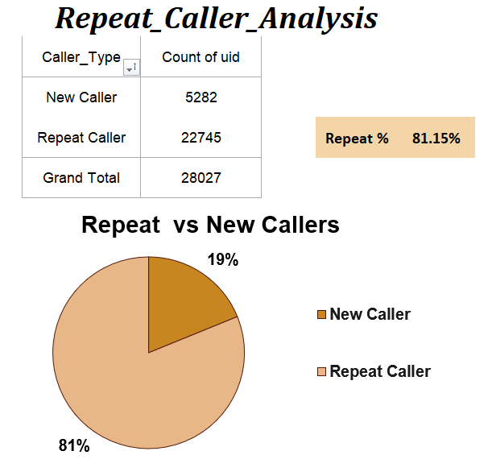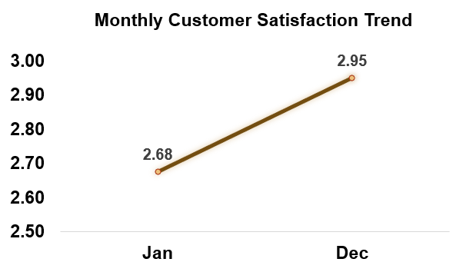
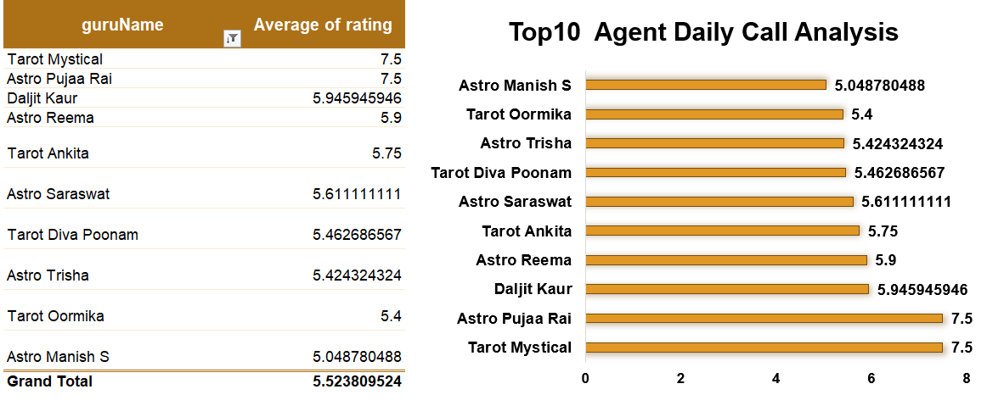
Figure 19: Call Volume, Customer Satisfaction, and Agent Performance Analysis

Q4. How can the call center improve its handling of peak call periods to ensure high customer satisfaction? Mention the functionality you will use for giving the suggestions, will it be any aggregated function or a visualization?
Answer:
The Daily Call Volume Trend analysis indicates that the call center experiences significant spikes in customer demand during certain periods. These peak call periods increase the risk of:
- Missed calls
- Long waiting times
- Uneven agent workload
- Reduced customer satisfaction
To improve handling of peak call periods, both aggregation-based analysis and visualization techniques were used to identify demand patterns and operational bottlenecks.

Recommendations to Improve Peak Call Handling

1. Dynamic Staffing During Peak Hours
Increase agent availability during identified high-demand periods to reduce missed calls and improve response time.
The Daily Call Volume Trend helped identify dates and time periods with the highest customer traffic.

2. Intelligent Call Routing
Implement AI-based or rule-based call routing systems to distribute calls evenly among available agents.
This will help:
- Reduce waiting time
- Improve workload balancing
- Increase operational efficiency

3. Performance-Based Agent Allocation
Assign high-performing agents during peak periods based on:
- Customer ratings
- Calls handled
- Resolution efficiency
Agent-wise performance analysis can help identify the most efficient agents for critical time slots.

4. Automated Callback & Self-Service Options
Introduce:
- Automated callback systems
- IVR support
- Self-service options
These tools can reduce call congestion and improve customer experience during high traffic periods.

5. Real-Time Monitoring Dashboard
Use live dashboards to monitor:
- Incoming call volume
- Missed calls
- Agent availability
- Peak-hour performance
This enables management to take immediate operational decisions during demand spikes.

Aggregation Functions Used:
COUNT()
COUNTIF()
AVERAGE()
SUM()
These functions were used to:
- Analyze daily call volume
- Measure agent workload
- Track missed calls
- Identify peak traffic periods

Visualizations Used:
- Line Chart (Daily Call Volume Trend)
- Bar Chart (Calls Handled per Agent)
- KPI Dashboard
- Pivot Table Analysis
A line chart was primarily used because it clearly highlights trends, fluctuations, and sudden spikes in call volume over time.

Key Insight:
The analysis indicates that peak-period challenges are mainly caused by:
- High customer demand
- Insufficient staffing during busy hours
- Uneven workload distribution
Proper staffing optimization, intelligent routing systems, and real-time monitoring can significantly improve customer satisfaction during high-demand periods.
Final Recommendation:
The call center should combine:
- aggregation-based workload analysis
- and visualization-driven trend monitoring
to proactively manage peak traffic periods and maintain high service quality.


Figure 20: Daily Call Volume Trend and Peak Period Analysis

Q5. Based on historical data, what strategic initiatives should be prioritized to improve efficiency and customer satisfaction?
Answer:
Historical analysis of AstroSage call center data revealed several operational challenges, including:
- Low call completion rate
- High missed call volume
- Uneven agent workload distribution
- Peak-hour congestion
- Variations in customer satisfaction ratings
These insights highlight the need for strategic operational improvements to enhance efficiency, service quality, and long-term customer retention.
Strategic Initiatives Recommended
1. Optimize Agent Capacity and Scheduling
The Daily and Monthly Call Volume analysis shows recurring peak demand periods where call traffic increases significantly.
Recommendation:
- Increase staffing during peak hours
- Implement dynamic shift scheduling
- Balance workload among agents
Expected Impact:
- Reduction in missed calls
- Faster response time
- Improved customer satisfaction
2. Improve Agent Training and Performance Management
Agent-wise performance analysis indicates major differences in call handling efficiency and customer ratings among agents.
Recommendation:
- Conduct targeted training programs
- Use top-performing agents as benchmarks
- Introduce performance monitoring systems
Expected Impact:
- Improved service quality
- Better first-call resolution
- Increased customer trust
3. Upgrade Call Centre Technology
Operational analysis highlights inefficiencies such as:
- High missed calls
- Uneven workload distribution
- Delayed response during peak periods
Recommendation:
Implement:
- Intelligent call routing
- CRM integration
- Automated callback systems
- Real-time monitoring dashboards
Expected Impact:
- Improved operational efficiency
- Faster issue resolution
- Better customer experience
4. Focus on Customer Retention Strategies
Repeat caller analysis shows that approximately 81% of customers are repeat users, indicating strong customer loyalty.
Recommendation:
- Personalized customer engagement
- Faster routing for repeat callers
- Loyalty-based service improvements
Expected Impact:
- Increased customer retention
- Higher customer satisfaction
- Long-term revenue growth

5. Reduce Missed Calls and Improve Completion Rate
The KPI analysis shows:
- Total Calls = 28,027
- Missed Calls = 24,574
- Call Completion Rate = 12.32%
Recommendation:
- Increase agent availability
- Improve queue management
- Monitor live call traffic
Expected Impact:
- Higher call completion rate
- Increased revenue opportunities
- Improved operational performance

Aggregation Functions Used:
COUNT()
SUM()
AVERAGE()
CORREL()
COUNTIF()
These functions were used to analyse:
- Call trends
- Agent workload
- Customer satisfaction
- Operational performance
Visualizations Used:
- KPI Dashboard
- Line Charts
- Bar Charts
- Pie Charts
- Pivot Table Analysis
These visualizations helped identify:
- Performance gaps
- Customer behaviour trends
- Peak demand periods
- Operational inefficiencies
Key Insight:
The historical data analysis indicates that operational efficiency and customer satisfaction are strongly connected to:
- staffing optimization,
- agent performance,
- technology infrastructure,
- and customer retention strategies.
Improving these areas simultaneously will help AstroSage achieve sustainable growth and better profitability.
Final Recommendation:
The call centre should prioritize:
- workforce optimization,
- targeted training,
- technology upgrades,
- and customer-focused service improvements
to improve operational efficiency, reduce missed calls, and enhance overall customer satisfaction.
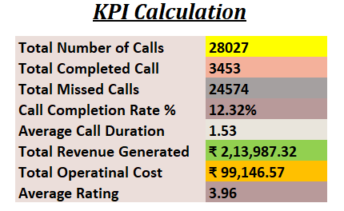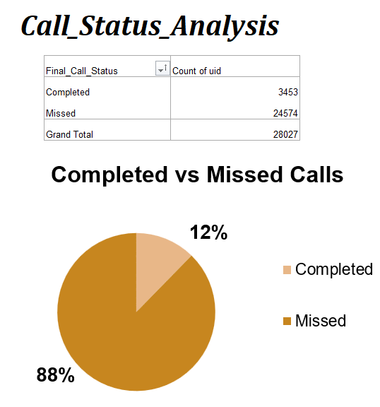
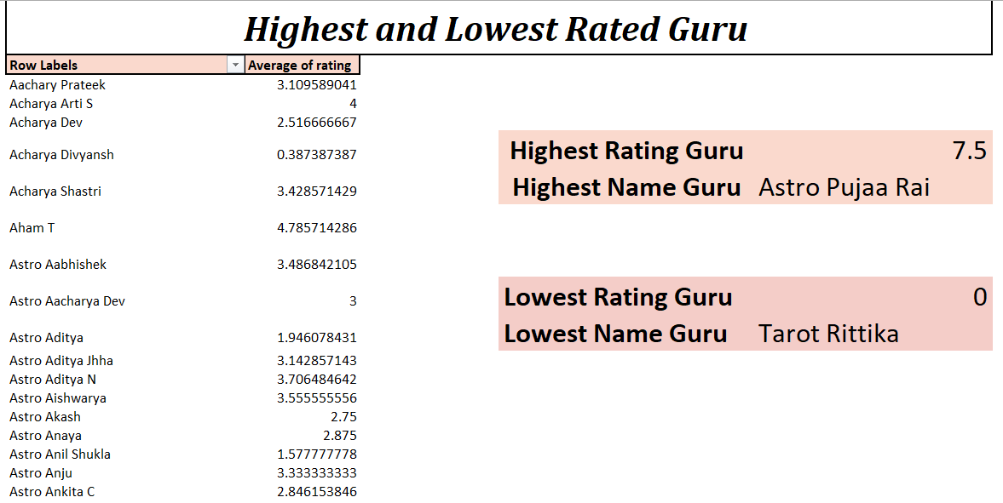
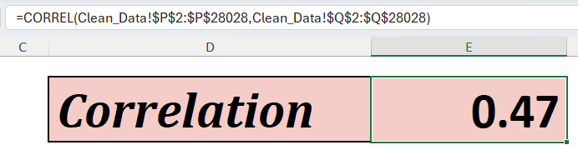
Figure 21: Historical Performance Analysis and Strategic Recommendations

Q6. What can be the key factors contributing to high customer satisfaction scores, and how can these be leveraged to improve overall performance? What is the basis for the suggestions? And mention how you decided if the satisfaction score affects the ratings.
Answer:
The analysis of AstroSage call center data identified several operational and service-related factors that contribute to higher customer satisfaction scores. These factors were evaluated using customer ratings, repeat caller analysis, agent performance analysis, and correlation analysis.
The findings indicate that customer satisfaction is strongly influenced by:
- Agent performance quality
- Effective call handling
- Customer retention
- Response efficiency
- Consultation experience
Key Factors Contributing to High Customer Satisfaction
1. High-Performing Agents
Agent-wise performance analysis shows that certain agents consistently receive higher customer ratings and handle larger call volumes efficiently.
Impact:
- Better communication quality
- Faster issue resolution
- Higher customer trust
How It Can Be Leveraged:
- Use top-performing agents as training benchmarks
- Implement performance-based mentoring programs
- Share best practices across teams
2. High Repeat Caller Percentage
The Repeat vs New Caller analysis shows that approximately 81% of customers are repeat callers.
Impact:
- Indicates strong customer loyalty
- Reflects positive consultation experience
- Demonstrates customer trust in services
How It Can Be Leveraged:
- Introduce personalized customer engagement
- Provide priority routing for repeat customers
- Build loyalty-based retention programs
3. Effective Call Handling
The analysis indicates that customers are more satisfied when:
- calls are handled efficiently,
- waiting time is lower,
- and consultation quality is better.
Impact:
- Improved customer experience
- Higher satisfaction ratings
- Better retention rate
How It Can Be Leveraged:
- Improve staffing during peak periods
- Reduce missed calls
- Optimize workload distribution
4. Service Consistency
Monthly satisfaction trend analysis shows fluctuations in customer ratings across different periods.
Impact:
- Inconsistent service quality affects customer trust
- High workload periods reduce satisfaction levels
How It Can Be Leveraged:
- Standardize service quality procedures
- Improve workforce planning
- Conduct regular quality monitoring
Basis for the Suggestions
The recommendations were based on:
- KPI Analysis
- Agent Performance Analysis
- Repeat Caller Analysis
- Customer Satisfaction Trend Analysis
- Correlation Analysis
These analyses helped identify patterns between operational performance and customer satisfaction outcomes.
How Satisfaction Score Impact on Ratings Was Determined
To determine whether customer satisfaction affects ratings, a correlation analysis was performed between:
- call handling metrics,
- customer interaction quality,
- and customer rating scores.
Formula Used:
=CORREL(call_duration_range, rating_range)
Result:
- Correlation Coefficient = 0.47
- Relationship Type = Moderate Positive Correlation
The positive correlation indicates that improved customer interaction quality and efficient call handling are associated with higher customer ratings.
This confirms that operational improvements directly influence customer satisfaction scores.
Aggregation Functions Used:
AVERAGE()
COUNTIF()
CORREL()
COUNT()
Visualizations Used:
- Bar Chart (Agent Performance Analysis)
- Pie Chart (Repeat vs New Callers)
- Line Chart (Monthly Satisfaction Trend)
- Correlation Analysis Chart
- KPI Dashboard
Key Insight:
The analysis demonstrates that customer satisfaction is not dependent on a single factor. Instead, it is influenced by:
- service quality,
- agent performance,
- operational efficiency,
- and customer engagement.
Improving these areas collectively can significantly enhance overall business performance and long-term customer retention.
Final Recommendation:
AstroSage should focus on:
- strengthening agent training,
- improving operational efficiency,
- reducing missed calls,
- and enhancing personalized customer experience
to achieve consistently high customer satisfaction scores and better long-term profitability.
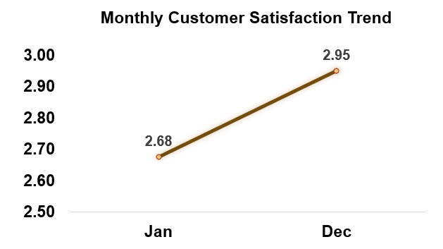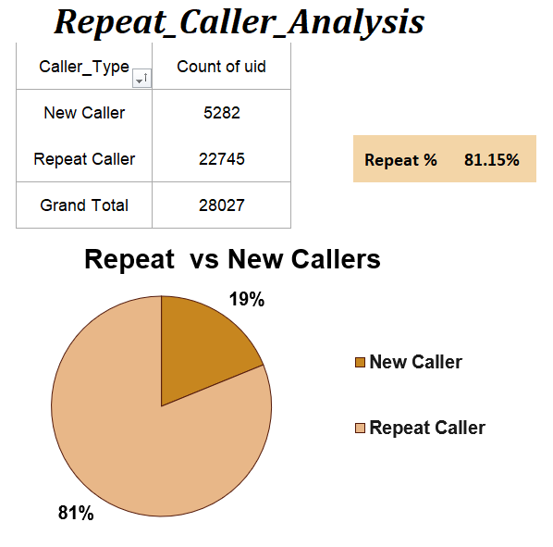
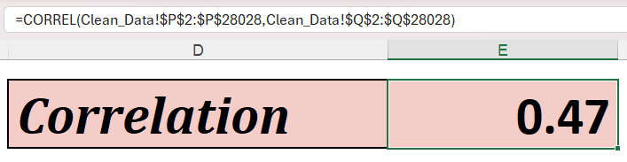
Figure 22: Customer Satisfaction, Repeat Caller, and Correlation Analysis

Q7. How should the call center balance the workload among agents to ensure optimal performance and avoid burnout?

Answer:
Agent-wise performance analysis revealed significant imbalance in workload distribution across agents. The Calls Handled per Agent analysis shows that some agents manage a disproportionately high number of calls, while others remain comparatively underutilized.
This imbalance increases the risk of:
- Agent burnout
- Reduced service quality
- Lower customer satisfaction
- Increased operational inefficiency
To ensure optimal performance and avoid burnout, the call center should adopt a balanced workload management strategy supported by data-driven monitoring and scheduling.

Recommended Approach for Workload Balancing
1. Dynamic Call Allocation
Calls should be distributed evenly among agents based on:
- Current workload
- Agent availability
- Performance capacity
This prevents overloading a small group of agents during peak periods.

2. Performance-Based Scheduling
Daily call volume analysis indicates recurring peak demand periods.
Recommendation:
- Assign experienced agents during high-demand hours
- Rotate schedules regularly
- Avoid assigning continuous peak-hour shifts to the same agents
Expected Impact:
- Reduced burnout risk
- Improved operational efficiency
- Better customer experience

3. Identify Underutilized Agents
Agent-wise call handling analysis shows that some agents handle fewer calls compared to others.
Recommendation:
- Provide targeted coaching
- Gradually increase workload for low-utilization agents
- Improve skill development programs
This helps achieve better workforce balance.

4. Real-Time Monitoring Dashboard
Use live dashboards to monitor:
- Calls handled per agent
- Active call queue
- Missed calls
- Peak-hour workload
Real-time monitoring enables supervisors to take immediate corrective actions during workload imbalance situations.

5. Mandatory Breaks and Shift Rotation
Continuous handling of high call volumes can reduce productivity and affect service quality.
Recommendation:
- Introduce scheduled breaks
- Rotate high-pressure shifts
- Implement workload caps during peak hours
Expected Impact:
- Better employee well-being
- Consistent service quality
- Reduced operational fatigue

Spreadsheet Functions Used:
COUNT()
COUNTIF()
AVERAGE()
RANK()
These functions were used to:
- Measure calls handled per agent
- Compare workload distribution
- Identify high-performing and underutilized agents
- Calculate average call handling trends

Visualizations Used:
- Bar Chart (Calls Handled per Agent)
- Line Chart (Daily Call Volume Trend)
- KPI Dashboard
- Pivot Table Analysis
A bar chart was primarily used to compare agent-wise workload distribution and identify workload imbalance visually.

Key Insight:
The analysis indicates that uneven workload distribution is one of the major operational challenges affecting both employee productivity and customer satisfaction.
Balancing agent workload through:
- smart scheduling,
- performance monitoring,
- and real-time operational tracking
can significantly improve service consistency and reduce burnout risk.
Final Recommendation:
AstroSage should implement:
- workload balancing strategies,
- dynamic scheduling,
- real-time monitoring systems,
- and targeted workforce optimization
to improve operational efficiency, maintain employee productivity, and ensure high customer satisfaction.

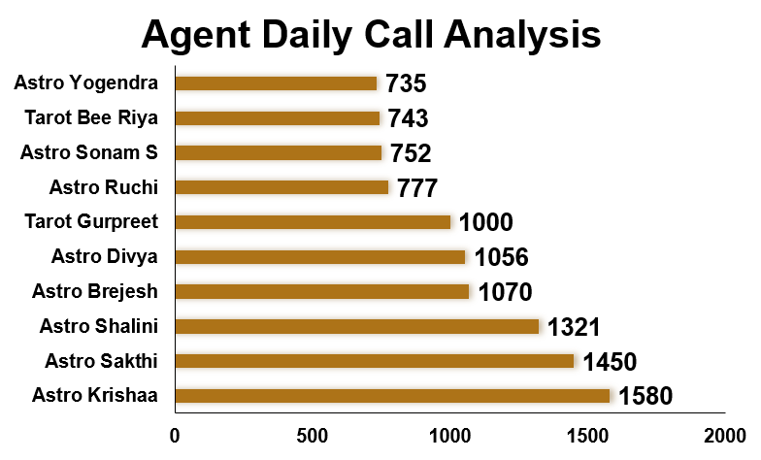
Figure 23: Agent Workload Distribution and Performance Analysis

Q8. What new technologies or tools could be implemented to enhance call center operations and customer service?

Answer:
Historical analysis of AstroSage call center data revealed several operational challenges, including:
- High missed call volume
- Low call completion rate
- Uneven agent workload distribution
- Peak-hour congestion
- Delays in customer response handling
These operational gaps indicate the need for technology-driven solutions to improve efficiency, automate processes, and enhance customer experience.

Recommended Technologies and Tools
1. Intelligent Call Routing System
AI-based call routing systems can automatically assign calls to the most suitable available agent based on:
- Agent availability
- Skill level
- Customer priority
- Previous interaction history
Benefits:
- Reduced waiting time
- Balanced workload distribution
- Faster issue resolution
- Improved customer satisfaction

2. CRM (Customer Relationship Management) Integration
The Repeat Caller Analysis shows that approximately 81% of users are repeat customers.
Integrating a CRM system can help:
- Store customer interaction history
- Provide personalized consultation experience
- Improve follow-up service quality
- Reduce handling time
Benefits:
- Better customer retention
- Improved service personalization
- Faster query resolution

3. Real-Time Performance Dashboards
Live dashboards can monitor:
- Incoming call volume
- Agent performance
- Missed calls
- Customer ratings
- Peak-hour traffic
Benefits:
- Faster managerial decision-making
- Real-time operational control
- Immediate response during demand spikes

4. Automated Callback System
During peak periods, customers often experience long waiting times.
Automated callback systems allow customers to:
- request callbacks,
- avoid waiting in queues,
- and receive support more efficiently.
Benefits:
- Reduced customer frustration
- Lower call abandonment rate
- Better customer experience

5. Interactive Voice Response (IVR) System
An IVR system can automate handling of simple customer queries without requiring agent intervention.
Benefits:
- Reduced agent workload
- Faster customer support
- Improved operational efficiency

6. Call Quality Monitoring & Analytics Tools
Speech analytics and call monitoring tools can analyze:
- customer sentiment,
- call quality,
- agent communication effectiveness,
- and recurring customer issues.
Benefits:
- Improved training quality
- Better service consistency
- Enhanced customer satisfaction

Spreadsheet Functions Used:
COUNT()
AVERAGE()
COUNTIF()
CORREL()
SUM()
These functions were used to identify:
- operational inefficiencies,
- customer retention patterns,
- workload imbalance,
- and customer satisfaction trends.

Visualizations Used:
- KPI Dashboard
- Daily Call Volume Trend
- Repeat vs New Caller Analysis
- Agent Performance Bar Chart
- Customer Satisfaction Trend Analysis
These visualizations helped identify operational bottlenecks and areas where technology adoption can provide maximum business impact.

Key Insight:
The analysis indicates that technology upgrades are essential to:
- reduce missed calls,
- improve response efficiency,
- balance agent workload,
- and strengthen customer retention.
Since customer loyalty is already high, implementing advanced operational tools can significantly improve both service quality and profitability.
Final Recommendation:
AstroSage should prioritize:
- AI-based call routing,
- CRM integration,
- real-time monitoring dashboards,
- callback automation,
- and quality analytics tools
to improve operational efficiency, customer experience, and long-term business scalability.

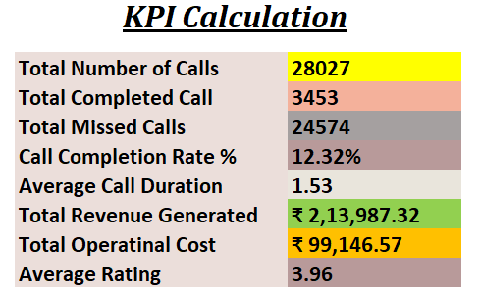

Figure 24: KPI Dashboard and Operational Technology Improvement Analysis

Q9. What metrics should be included in the final dashboard to comprehensively view call centre performance and guide investment decisions?
Answer:
The final executive dashboard should provide a complete overview of operational efficiency, customer satisfaction, agent performance, and financial performance to support data-driven management and investment decisions.
The dashboard was designed using KPI cards, Pivot Tables, slicers, and interactive visualizations to help management quickly identify operational gaps, customer behaviour patterns, and profitability trends.

1. Operational Performance Metrics
Metrics Included:
- Total Calls
- Completed Calls
- Missed Calls
- Call Completion Rate (%)
- Daily Call Volume
- Monthly Call Volume
Purpose:
These metrics help management monitor:
- operational efficiency,
- customer demand trends,
- and peak traffic periods.
Business Impact:
High missed calls and low completion rates indicate staffing or operational bottlenecks that require immediate attention.

2. Agent Performance Metrics
Metrics Included:
- Calls Handled per Agent
- Average Calls per Agent per Day
- Agent Utilization
- Guru-wise Customer Ratings
Purpose:
These metrics help evaluate:
- workload distribution,
- employee productivity,
- and service quality.
Business Impact:
Identifying top-performing and underperforming agents helps management improve training programs and workforce planning.

3. Customer Satisfaction & Retention Metrics
Metrics Included:
- Average Customer Rating
- Monthly Satisfaction Trend
- Repeat vs New Callers (%)
- Customer Retention Rate
Purpose:
These metrics measure:
- customer experience,
- service quality,
- and customer loyalty.
Business Impact:
A high repeat caller percentage indicates strong customer trust and long-term retention potential.

4. Financial & Profitability Metrics
Metrics Included:
- Total Revenue
- Operational Cost
- Net Profit
- Revenue by Product Category
Purpose:
These metrics help management evaluate:
- profitability,
- operational spending,
- and revenue generation efficiency.
Business Impact:
Financial KPIs ensure that operational improvements also contribute to sustainable business growth and better return on investment.

5. Peak Load & Operational Trend Metrics
Metrics Included:
- Hourly Call Distribution
- Date-wise Call Trend
- Peak Traffic Analysis
- Call Queue Trend
Purpose:
These metrics help identify:
- high-demand periods,
- operational congestion,
- and staffing requirements.
Business Impact:
Understanding peak traffic behavior helps optimize workforce scheduling and reduce missed calls.

Aggregation Functions Used:
COUNT()
SUM()
AVERAGE()
COUNTIF()
CORREL()
These functions were used to calculate:
- KPIs,
- operational trends,
- customer satisfaction metrics,
- and financial performance indicators.

Visualizations Used:
- KPI Cards
- Line Charts
- Bar Charts
- Pie Charts
- Pivot Tables
- Interactive Dashboard with Slicers
Slicers such as:
- Year
- Website
- Consultation Type
were added to make the dashboard interactive and support management-level decision-making.

Key Insight:
The dashboard should combine:
- operational,
- customer,
- agent,
- and financial metrics
into a single interactive view to help management:
- monitor performance,
- identify inefficiencies,
- improve customer satisfaction,
- and make effective investment decisions.
Final Recommendation:
A well-designed interactive dashboard with KPI cards, trend analysis, financial metrics, and customer insights can significantly improve operational monitoring and support strategic decision-making for long-term profitability and business growth.

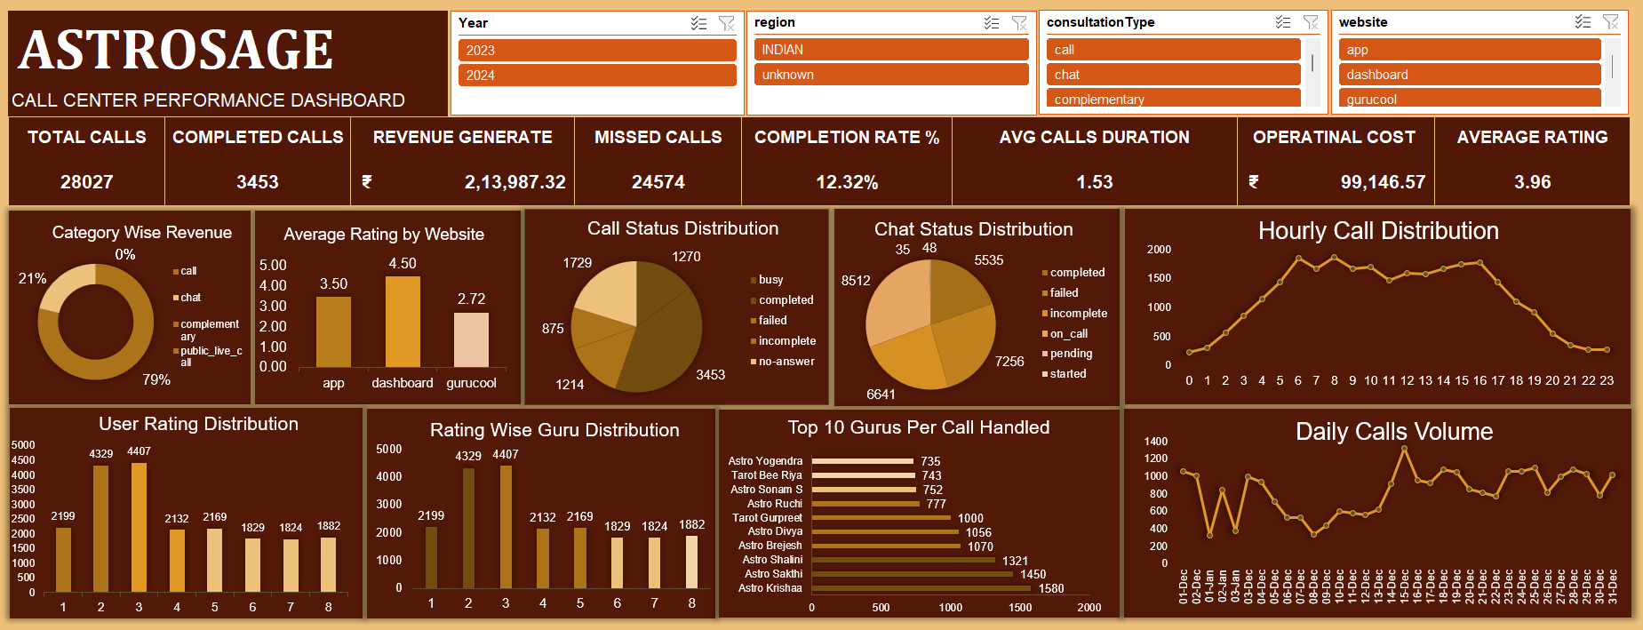
Figure 25: Final Executive Dashboard and KPI Analysis

Q10. How would you allocate a 1 crore rupee investment to optimize operational efficiency, enhance customer satisfaction, and boost profitability, and what analysis-based recommendations would you offer to support this?

Answer:

Based on the historical analysis of AstroSage call center data, a balanced and data-driven investment strategy is recommended to improve operational efficiency, customer satisfaction, and long-term profitability.
The analysis identified several operational challenges:
- Low call completion rate (12.32%)
- High missed call volume (24,574 missed calls)
- Uneven agent workload distribution
- Peak-hour congestion
- Strong customer retention (81% repeat callers)
Although the call center is profitable, these operational inefficiencies limit its growth potential. Therefore, the ₹1 crore investment should be allocated strategically across staffing, training, technology, and operational monitoring.

Recommended Investment Allocation
1. Hiring Additional Agents — ₹40 Lakhs (40%)
Reason:
- High missed call volume
- Insufficient staffing during peak periods
- Uneven workload distribution
Analysis-Based Justification:
Daily call trend and agent workload analysis indicate that existing staffing capacity is unable to handle peak customer demand efficiently.
Expected Benefits:
- Reduced missed calls
- Faster customer response time
- Improved call completion rate
- Better customer satisfaction

2. Training & Performance Improvement — ₹25 Lakhs (25%)
Reason:
- Significant variation in agent performance
- Inconsistent customer satisfaction ratings
Analysis-Based Justification:
Agent-wise performance analysis shows that some agents consistently perform better than others. Structured training programs can improve communication quality and operational consistency.
Expected Benefits:
- Improved service quality
- Better first-call resolution
- Increased customer trust
- Reduced customer complaints

3. Technology & Automation Upgrades — ₹25 Lakhs (25%)
Reason:
- High repeat caller dependency
- Peak-hour operational congestion
- Need for faster issue resolution
Recommended Technologies:
- Intelligent Call Routing
- CRM Integration
- Automated Callback Systems
- Real-Time Monitoring Dashboards
Analysis-Based Justification:
Repeat caller analysis shows that 81% of users are repeat customers. Technology upgrades can enhance customer experience and improve operational efficiency.
Expected Benefits:
- Reduced waiting time
- Better customer retention
- Improved workload balancing
- Faster operational decision-making

4. Analytics, Monitoring & Contingency Planning — ₹10 Lakhs (10%)
Reason:
Continuous monitoring is required to track operational performance and investment effectiveness.
Analysis-Based Justification:
KPI dashboards and trend analysis highlight the importance of real-time operational monitoring for managing peak demand and improving productivity.
Expected Benefits:
- Better KPI tracking
- Improved operational control
- Faster issue identification
- Long-term scalability

Analysis-Based Recommendations
• Improve Staffing During Peak Hours
Use daily and hourly call trend analysis to optimize workforce scheduling during high-demand periods.
• Reduce Missed Calls
Focus on improving call completion rates by increasing staffing capacity and implementing callback systems.
• Strengthen Customer Retention
Leverage the high repeat caller percentage through personalized service and CRM integration.
• Improve Agent Productivity
Introduce performance-based training and workload balancing strategies.
• Enhance Operational Monitoring
Use real-time dashboards and KPI tracking to improve management decision-making.

Aggregation Functions Used:
COUNT()
SUM()
AVERAGE()
COUNTIF()
CORREL()
These functions were used to analyse:
- operational performance,
- customer retention,
- profitability,
- and agent productivity.

Visualizations Used:
- KPI Dashboard
- Line Charts
- Bar Charts
- Pie Charts
- Pivot Table Analysis
These visualizations helped identify:
- operational bottlenecks,
- customer behavior trends,
- peak demand periods,
- and investment priority areas.

Key Insight:
The analysis indicates that operational efficiency, customer satisfaction, and profitability are interconnected. A balanced investment strategy across staffing, training, technology, and monitoring will provide the highest long-term business impact.
Final Recommendation:
AstroSage should implement a balanced investment strategy focused on:
- workforce expansion,
- targeted training,
- technology modernization,
- and data-driven operational monitoring
to improve customer satisfaction, reduce missed calls, enhance efficiency, and maximize long-term profitability.

Final Dashboard Note:

The final dashboard was designed with interactive slicers for Year and Website/Region selection to allow management to analyze performance trends dynamically over different time periods and customer segments. This interactive functionality enables users to filter and explore operational, financial, and customer-related metrics efficiently during long-term strategic discussions and decision-making sessions.
The dashboard includes:
- Dynamic slicers
- KPI cards
- Trend analysis charts
- Agent performance visualizations
- Customer satisfaction analysis
- Revenue and operational cost insights
This interactive and user-friendly dashboard helps management:
- Monitor operational efficiency
- Identify peak call periods
- Evaluate customer satisfaction trends
- Analyze agent productivity
- Support investment and business strategy decisions
Key Insight:
The integration of slicers, Pivot Tables, KPI metrics, and visualizations makes the dashboard highly interactive, flexible, and suitable for detailed business analysis and long-term operational planning.


Figure 26: Final Interactive Executive Dashboard with Dynamic Slicers

Conclusion & Acknowledgment

This project demonstrates the application of spreadsheet-based analysis,
pivot tables, dashboards, and business insights to solve real-world
operational problems.

Thank you for the opportunity to present this analysis.

Prepared by:
Chandni Kalchuri

